Microwave Optics

2017-02-015

Cory Wolfe

Lab Partners: Ryan Goulden and Marshall Loper

For this experiment microwaves were sent and received with miscellaneous obstructions. The hypothesis of this experiment is that, while not being visible, microwaves still exhibit similar properties to light, as they are both electromagnetic waves.

This experiment required a Microwave emitter and receiver, metal sheets with either one or two slits, a quadrant apparatus, a block of wood, foam and plexiglass. The equipment was arranged in various positions to monitor the transmission and reflection of microwaves through miscellaneous media. An example of the apparatus while reflecting is shown in Figure 1. Simple modifications can be made to test different media and reflecting angles. Helpful equations include:

$P_{\text{ABS}}=P_{0}−\left(P_{A}+P_{R}\right)\text{Absorbed Power Equation}$

$θ_{B}=\tan^{−1}\left(\frac{n_{2}}{n_{1}}\right)\text{Brewster's Angle Equation}$

Figure 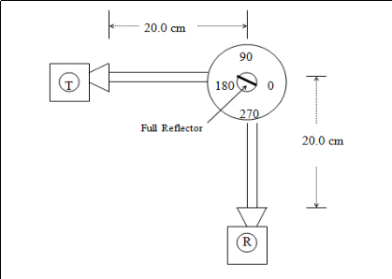1: Diagram of Lab Setup

The procedure for this experiment involved initially setting the transmitter and receiver opposite eachother, 40 cm apart. Then the Receiver was calibrated to read 100%, the units used for the Receiver in this lab, in this arrangement. After this is done a series of absorbers (the afformentioned board and wet foam) were placed inbetween the devices at a 45 degree angle, then the transmitter was rotated to be 90 degrees from the receiver. The reading of the transmitter was recorded in each situation, and is shown in Table 1.

After this was completed the transmitter and receiver were removed from the apparatus and positioned in such a way to use the the table as a reflector. They were then rotated in order to find maximum points. This was used to determine how the waves were polarized. After this was completed the apparatus was set up as shown in Figure 1. The maximum value was found and both angles of incidence and reflection at fourty-five degrees, they were the same due to the geometry of the angle. After this was completed a similar layout was used, but with a half reflector in the center and full reflector on the remaining ninety degree increments. One of the full reflector was moved forward with both a half reflector and a plexiglass sheet in the center. The data was recorded and is shown in Table 2.

|  |  |  |
| --- | --- | --- |
|  | Board | Foam |
| P0 (%) | 100 | 100 |
| PA (%) | 80 | 70 |
| PR (%) | 20 | 30 |
| PABS (%) | 0 | 0 |

Table 1: Reflection and Absorption Data

|  |  |  |
| --- | --- | --- |
| Length from center (cm) | Sheet (%) | Plexiglass (%) |
| 15.5 | 76 | 17.5 |
| 15.4 | 76.5 | 16 |
| 15.3 | 77.5 | 15 |
| 15.2 | 77 | 16 |
| 15.1 | 77.5 | 17.5 |
| 15 | 76.5 | 20 |
| 14.9 | 76 | 22 |
| 14.8 | 75.5 | 24 |
| 14.7 | 74.5 | 26 |
| 14.6 | 73 | 27.5 |

Table 2: Half-Reflector and Plexiglass

In this lab the group developed an understanding of electromagnetic waves. The group learned about the reflection of various materials and also found that the waves being reflected by the table were vertically poloarized, leading to a reading of 0%, unless turned. The wavelength of the microwaves the group found was 7 mm, which falls within or very close to the range in which microwaves fall.